|  |  |  |  |
| --- | --- | --- | --- |
| Name:  Teacher : | ____________________________________  ______________________ | | Date:_________ |
|  | **Year 12 Essentials**  /50  **Pythagoras & Trigonometry**  **Full working out MUST be shown to get full marks for each question.** | | |
| **Total Time:** | 50 minutes |  | |
| **Weighting:** | 6% |
| **Equipment:** | Pen, pencil, ruler, scientific calculator, 1- 2-sided page of notes | | |

1. Which of the following is a right angled triangle, and explain your reasoning. **[4 marks]**

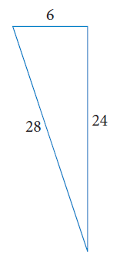

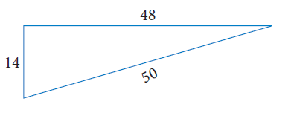

1. Use the triangle $∆$ DXP to answer the following questions **[3 marks]**
2. 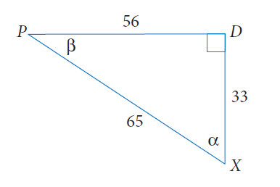How long is the hypotenuse?
3. What is the length of the side opposite to $α$?
4. How long is the side adjacent to $β$
5. Determine the lengths of the sides marked with pronumerals. Express your answers to 1 decimal place.

**[6 marks]**

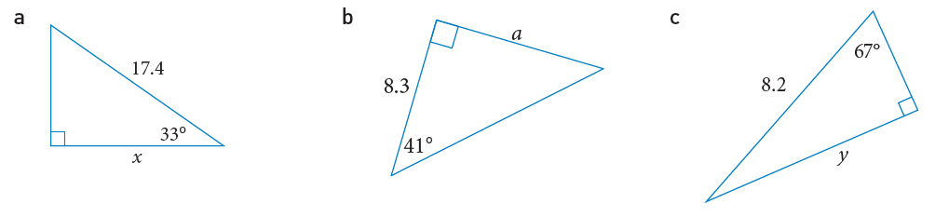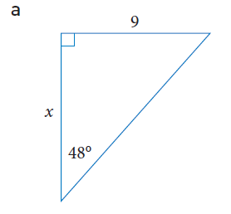

1. Determine the size of $∠a$, correct to the nearest degree. **[4 marks]**

a

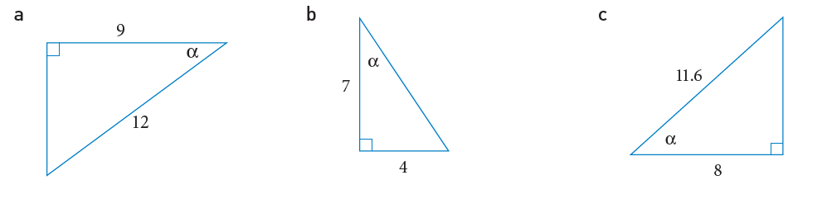

b

1. The council is going to build a children’s slide in the park. The top of the slide will be 2.6 m high and the slide will make an angle of 31 $°$ with the ground. Calculate the length of the slide, correct to 2 decimal places.

**[3 marks]**

1. Sean is standing 4.3m away from a tree. The angle of elevation, from the ground to the top of a tree is $24°$. How tall is the tree? **[3 marks]**
2. Calculate the length of $x$ and $y$, correct to 1 decimal place **[4 marks]**

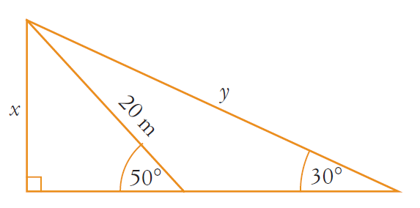

1. 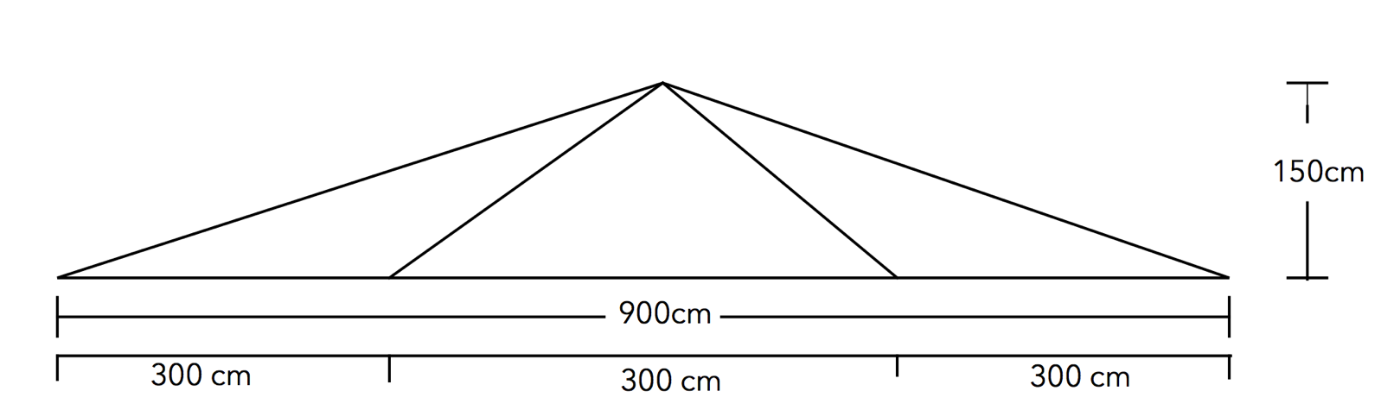Sam builds a roof support. It is 900cm wide, 150cm tall and is supported by 4 diagonal beams. The two outer beams are the same length, and the two inner beams are the same length. How much total wood would Sam need to build their structure? **[6 marks]**
2. Sarah stands on top of a totem pole that is 45m tall. She sees another smaller pole in the distance that she knows is 7m tall. She works out that it is at an angle of depression of 18 degrees. How much rope would she need to make a zipline between the two poles? **[4 marks]**
3. From a lighthouse 150m above sea level, the lighthouse keeper observes a boat at an angle of depression of $25°$ and another boat at an angle of depression of $32°$. Find the distance that separates the boats. **[7 marks]**
4. Several cars underwent a brake test and their age was measured against their stopping distance. The scatter plot shows the results and a line of best fit that approximates the positive correlation. **[4 marks]**

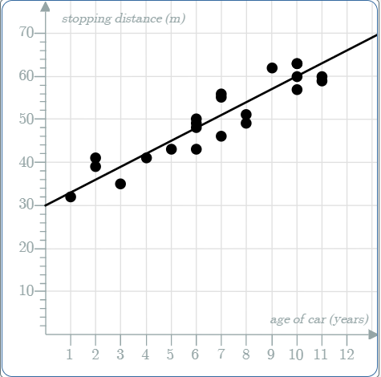

1. According to the trend line, what is the stopping distance of a car that is 6 years old?
2. Use the trend line to estimate the stopping distance of a car that is 7.5 years old
3. Comment on whether the estimation in part b is reliable or unreliable?
4. ‘An increase in the Global Average Temperature has a strong positive effect on the number of pirates at sea.’

Make a comment about this statement in relation to the graph **[2 marks]**

